**TITLE:**

Smart Cane for Enhanced Safety and Environmental Awareness

**AUTHORS**

[Amir Muizzuddin Bin Noraidil Razman], [Muhammad Haikal Hanif Bin Abdul Razak] , [Ahmad Ilham Bin Abdul Aziz], Department Of Mechatronic Engineering , International Islamic University Malaysia ,

## ABSTRACT

This project presents the design and development of a Smart Cane system aimed at improving the safety and mobility of visually impaired users. The proposed system integrates fall detection, obstacle detection, and automatic night-time illumination using an ESP32 microcontroller as the central processing unit. A motion sensor module (MPU6050) is employed to detect accidental falls and trigger an emergency alert through a buzzer. An ultrasonic sensor (HC-SR04) is used to detect obstacles in front of the user and provide timely feedback. Additionally, an automated LED torch controlled by a light-dependent resistor (LDR) ensures visibility in low-light or dark environments. When a fall is detected, the system automatically sends an emergency alert with location information to a registered guardian. Additionally, a blinking LED system improves user visibility during night-time road crossing.Bluetooth communication is implemented to enable data transmission between the Smart Cane and a mobile phone. Experimental results demonstrate that the system operates reliably and enhances user safety, awareness, and confidence during daily mobility.

## 1. INTRODUCTION

Walking canes are a major part of everyday mobility for those with visual impairments. Although the conventional white cane works well for identifying impediments at ground level, it is insufficiently aware of environmental risks such elevated barriers, slick surfaces, and emergency circumstances. Additionally, traditional canes don't help notify others when a user falls or needs help, especially at night or in remote locations.

According to earlier research, smart cane systems with sensors and feedback systems can greatly increase mobility and lower collision rates when compared to conventional canes. According to research published in the International Journal of Design, visually impaired people can move more safely with smart canes that combine vibrotactile feedback and sensor-based detection as long as usability, weight, and feedback clarity are carefully taken into account.

Fall detection, emergency alarms, and visibility functions can now be incorporated into a small, reasonably priced assistive gadget thanks to developments in embedded systems and wireless communication. The goal of this project is to create a smart cane that will increase walking safety, particularly at night, and guarantee prompt aid by alerting guardians in an emergency.

## 2.METHODOLOGY

### 2.1 Project Development

Overall a block diagram is an overview of the entire system such that the connection between input, output and microcontroller can be explained. The project on the smart cane has 3 system which can be categorized as RDS (Rain Detection System), ODS (Obstacle Detection System) and FAS (Falling Alert System). The block diagram will start with a simple push button to turn on the system. On the other hand, Fig 2 will show the flow of ODS and RDS that will use Arduino as microcontroller and LAS will use ESP 32 as microcontroller. The following single diagram demonstrates the collaboration of all the systems that secure the efficiency of the project in general . Fig 3 indicates the flow chart of the all systems that represents the work principle of Smart Cane project.

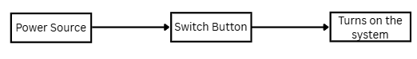

**Fig 1.** *Indicator that the Smart Cane turned On*

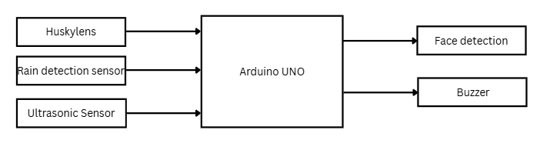

**Fig 2.**

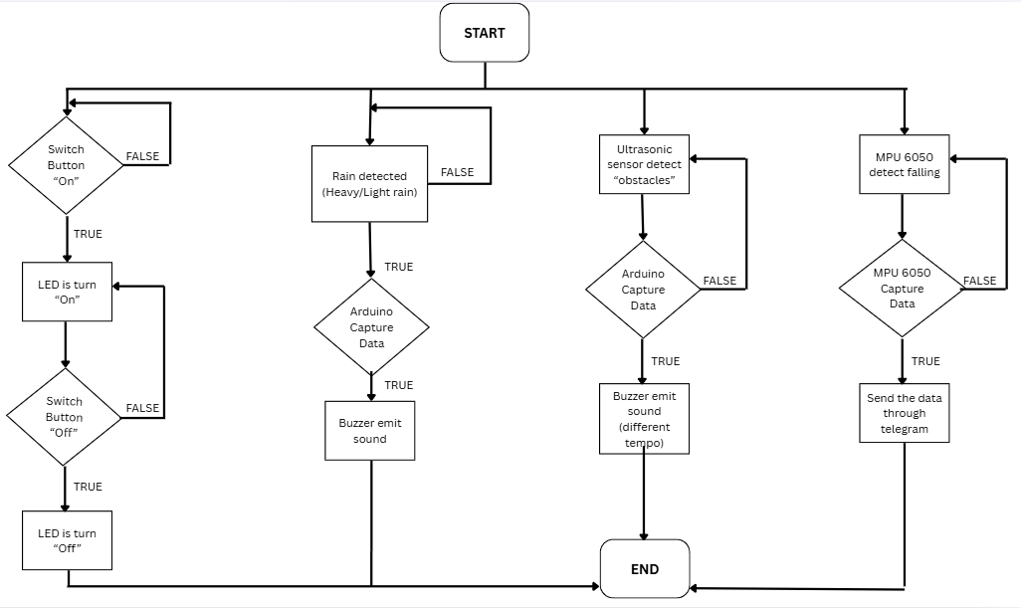

**Fig 3.**

### 2.2 SCHEMATIC DIAGRAM AND PROTOTYPE SETUP:

Figure 4 illustrates the schematic diagram of the smart cane system, which is now powered by two separate Arduino microcontrollers to manage its various functions efficiently. The electrical design is divided into two main subsystems. The first Arduino controller is dedicated to environmental and obstacle detection. It is connected to a Husky Lens AI camera for visual recognition, a Rain Sensor to detect precipitation, and an HC-SR04 Ultrasonic Sensor for obstacle detection. This subsystem activates a specific buzzer to alert the user of detected obstacles or rain.

The second Arduino controller is solely responsible for the fall detection system. It is interfaced with an MPU6050 accelerometer and gyroscope module to monitor the cane's orientation and acceleration. If a fall is detected, this controller triggers a separate, distinct buzzer to provide an immediate auditory alert. Both Arduinos are powered by a common battery source through a breadboard, with a single ON/OFF switch to control the entire system. Figure 1 (from the previous step) exhibits the prototype design setup, showing the physical arrangement of these components on the cane shaft and handle to ensure ergonomic use and optimal sensor placement.

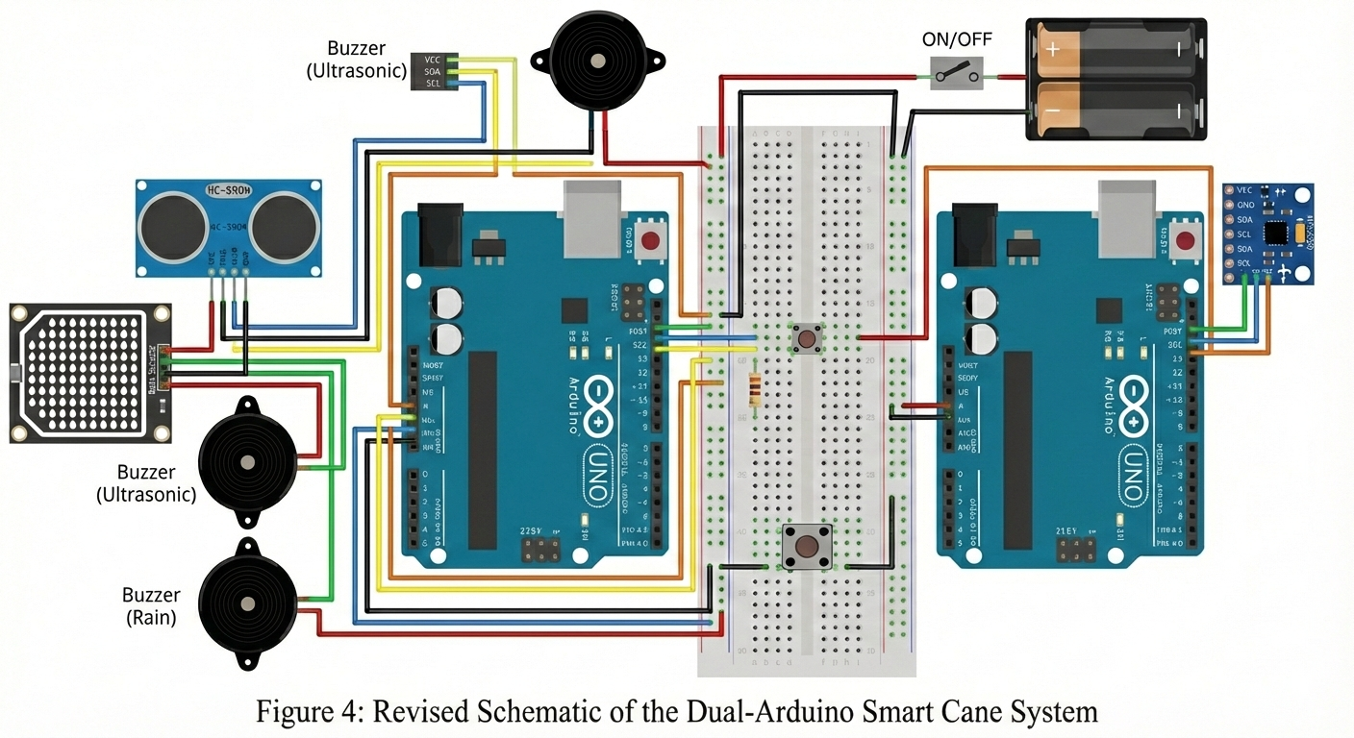

**Fig. 4**

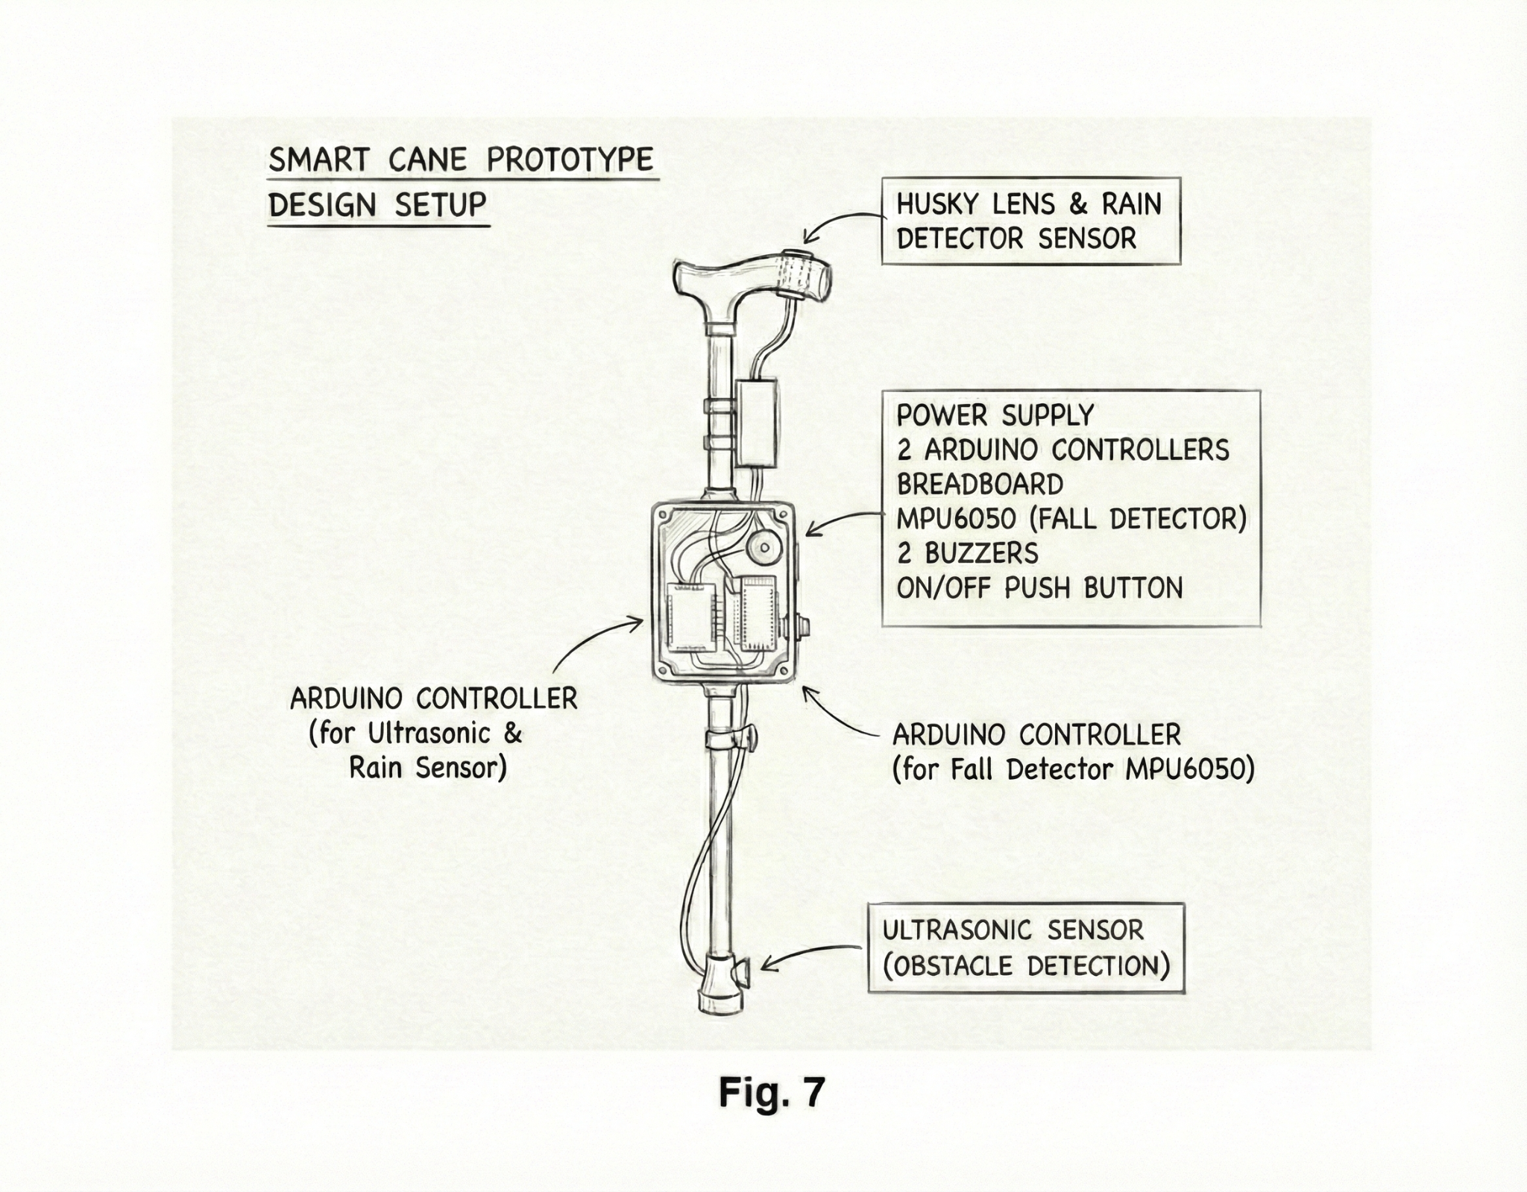

**Fig. 5**

**3. RESULTS ANALYSIS**

### 3.1 Rain Detection System Analysis

The functionality of this system is to detect whether there is rain or not. Since Malaysia always has peculiar and unpredictable weather conditions. Even if we plan ahead, rain would simply hinder our plan to continue our life ideally. So with the implementation of this system in our cane, it would help the blind people significantly so they do not need to be wet just simply to know whether there is rain or not. Our system consists of three readings. If the value from the rain sensor captures less than 700 it would print an output “Light Rain” and will emit a loud buzzer sound. If it captures less than 400 it would print an output “Heavy Rain” and will also emit a loud buzzer sound.

**Table 1** The result obtained from the rain sensor

| **Type of Rain** | **Figure of Testing** | **Observation** |
| --- | --- | --- |
| No Rain |  | Reading value is more than 700, it will print output, no buzzer will emit during this |
| Light Rain |  | Reading value is between 700 and 400, It shows there is Light Rain, Buzzer will emit |
| Heavy |  | Reading value is less than 400, It shows there is Heavy Rain, Buzzer will emit |

### 3.2 Obstacle Detection System Analysis

In our project we also put an Obstacle Detection System. It is a basic requirement for all the assisting tools for the visually impaired. However our Obstacle Detection could detect if the object is 50 cm or less. It would alert the users if they are near an obstacle or object by emitting a buzzing sound. Our project intends to increase mobility and independence of a visually impaired person. It is important to set a not too late or too early range between the cane and the obstacle since it could cause confusion depending on a situation that they are currently in. Our group agrees that 50 cm is appropriate.

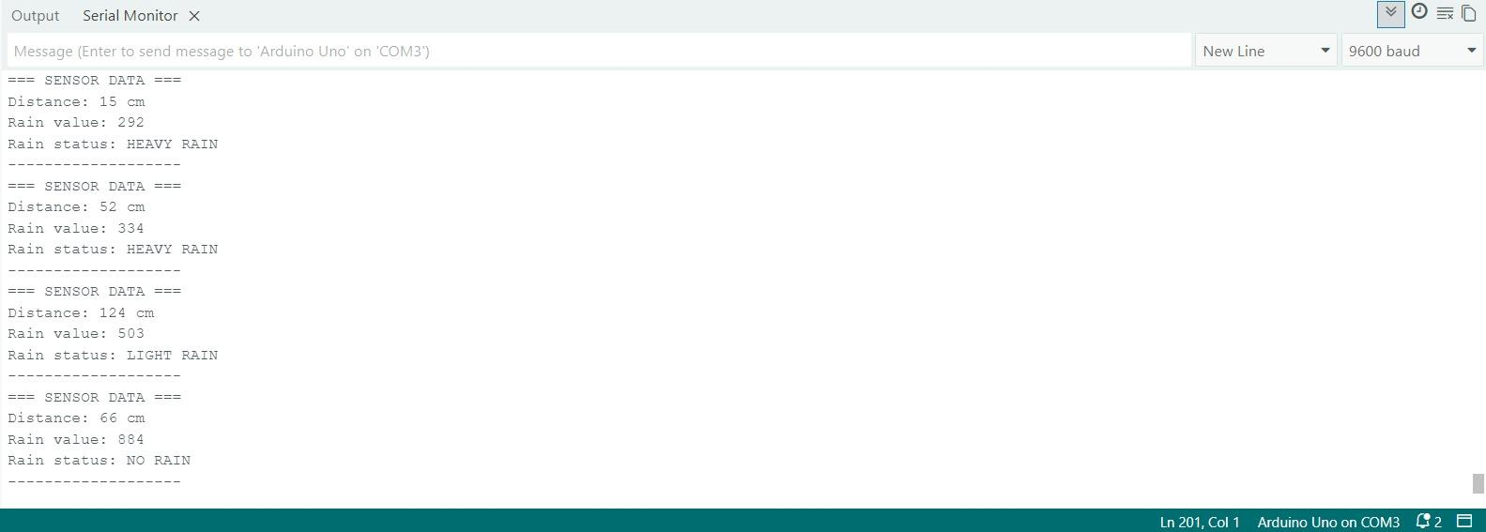 



**Fig 6.** Show various reading obtained from the ultrasonic sensor

**Table 2** Show condition of Ultrasonic Sensor and Buzzer in various distance

| **Distance (cm)** | **Ultrasonic Sensor Status** | **Buzzer Status** |
| --- | --- | --- |
| 100 | Active | No Sound |
| 75 | Active | No sound |
| 50 | Active | Active |
| 25 | Active | Active |

### 3.3 Fall Detection Analysis

In our project we put a Fall Detection System using MPU6050. First it will take a few seconds to calibrate it and then if the user falls, the MPU6050 will take a few seconds to notice whether the user fell or not. The main reason to not detect instantaneously is to prevent the system from spamming the user falling down every time the cane has fallen down. After the cane successfully detects the user is currently down, it would send notification through telegram.

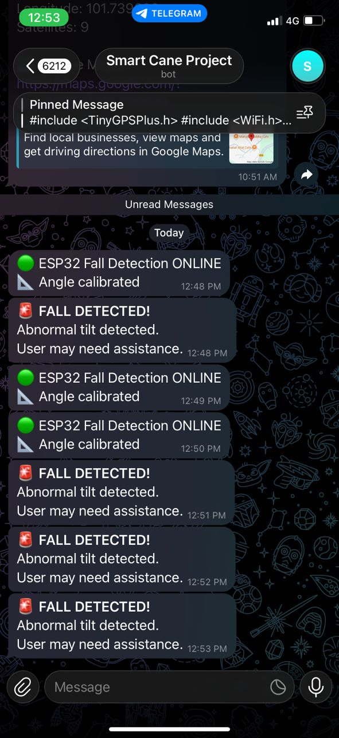

**Fig 7.** Shows on telegram side where it calibrating everytime the cane turned on and when the user fall

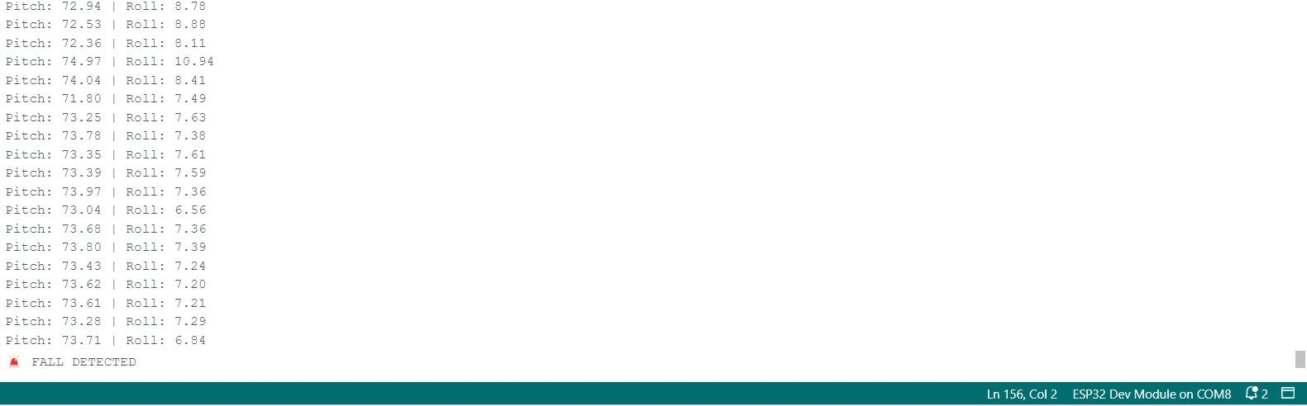

**Fig 8.** Showing on the Arduino side when the value is falling down

**4.0 DISCUSSION**

The objective of this project was to develop a Smart Cane capable of enhancing the safety and mobility of visually impaired users through three core subsystems: Rain Detection, Obstacle Detection, and Fall Detection. The results obtained from the serial monitor and physical testing confirm that the system functions within the desired parameters, though specific calibration choices played a crucial role in the system's effectiveness.

**4.1 Rain Detection System Analysis**

The rain detection subsystem utilized an analog sensor to measure moisture levels, categorizing the output into three states: "No Rain," "Light Rain," and "Heavy Rain."

As shown in Table 1, the threshold values were set at 700 and 400.

* **Calibration Logic**: The choice of <700 for Light Rain and <400 for Heavy Rain proved effective in filtering out false positives (such as high humidity) while remaining sensitive enough to detect actual precipitation.
* **User Feedback**: The decision to trigger the buzzer only when the reading drops below 700 is critical for user experience. By ignoring values above 700, the system prevents unnecessary auditory distractions during dry or merely humid conditions.
* **Implication**: This feature successfully meets the objective of giving the user early warning to seek shelter, which is particularly vital in Malaysia’s unpredictable tropical climate.

#### **4.2 Obstacle Detection System Analysis**

The ultrasonic sensor performance, summarized in Table 2, demonstrates a binary safety approach. While the sensor successfully measured distances up to **100 cm,** the buzzer activation was restricted to objects within **50 cm**.

* **Distance Threshold:** The selection of a 50 cm threshold is a trade-off between safety and usability. If the threshold were set to 100 cm (1 meter), the user would likely be overwhelmed by constant buzzing in crowded environments, leading to "alert fatigue" and confusion.
* **Response Time:** At a normal walking pace, 50 cm provides sufficient reaction time for the user to stop or alter their path without causing a collision.
* **Consistency:** The data in Figure 6 shows consistent distance readings, indicating that the sensor is reliable for detecting solid obstacles. However, the system relies on the reflection of sound waves, so soft or angled surfaces might occasionally yield less accurate readings, a known limitation of ultrasonic technology.

#### **4.3 Fall Detection System Analysis**

The Fall Detection System, powered by the MPU6050 accelerometer/gyroscope, presented the most complex challenge: differentiating between a user falling and the cane simply being dropped.

* **Algorithm and Latency:** As noted in the results, the system does not trigger instantaneously. The introduction of a delay (calibration time) after a tilt is detected is a crucial logic feature. By waiting a few seconds to verify the orientation (Pitch/Roll data in Figure 8) remains abnormal, the system effectively filters out momentary jostles or the cane slipping from a hand.
* **IoT Integration:** The successful transmission of the "FALL DETECTED" alert to Telegram (Figure 7) validates the ESP32's connectivity capabilities. This transforms the cane from a passive tool into an active safety device.
* **Significance:** This feature addresses the critical risk of a visually impaired person being injured and unable to call for help. The automated location/status update ensures that caregivers are notified even if the user is incapacitated.

#### **4.4 General System Integration**

The integration of these three systems into a single microcontroller setup requires careful management of processing resources. The results indicate that the loop cycle is fast enough to handle sensor polling (Rain and Ultrasonic) while simultaneously monitoring the MPU6050 interrupt or state. The system successfully prioritizes immediate physical threats (obstacles) and critical emergencies (falls) while providing environmental awareness (rain) without significant latency.

## 5. Conclusion

In conclusion, this project successfully designed and implemented a Smart Cane that effectively addresses key mobility and safety challenges faced by visually impaired individuals. By integrating environmental monitoring, obstacle avoidance, and emergency response into a single IoT-enabled device, the system fulfills its primary objective of enhancing user independence.

The experimental results validate the functionality of all three core subsystems:

1. **Rain Detection:** The system successfully differentiates between light and heavy rain, providing timely alerts that allow users to react to Malaysia’s unpredictable weather conditions.
2. **Obstacle Detection:** The ultrasonic sensor proved reliable in detecting objects within the critical 50 cm range, offering a necessary safety buffer to prevent collisions in dynamic environments.
3. **Fall Detection:** The integration of the MPU6050 with Telegram connectivity is a significant safety advancement. The system’s ability to distinguish between a fall and a false alarm, and subsequently notify caregivers, transforms the cane from a passive guide into an active life-saving device.

Overall, the prototype demonstrates that low-cost microcontrollers like the ESP32 and Arduino can be effectively utilized to create a robust assistive technology solution. The Smart Cane not only navigates physical barriers but also provides a digital safety net, significantly improving the quality of life and confidence of the user.

**Video Demonstration**

<https://youtube.com/shorts/m1Qm7WXPuBg?feature=share>